Indian Run Escaped Prescribed Fire

Facilitated Learning Analysis – October 2008

Final Report – February 2, 2009

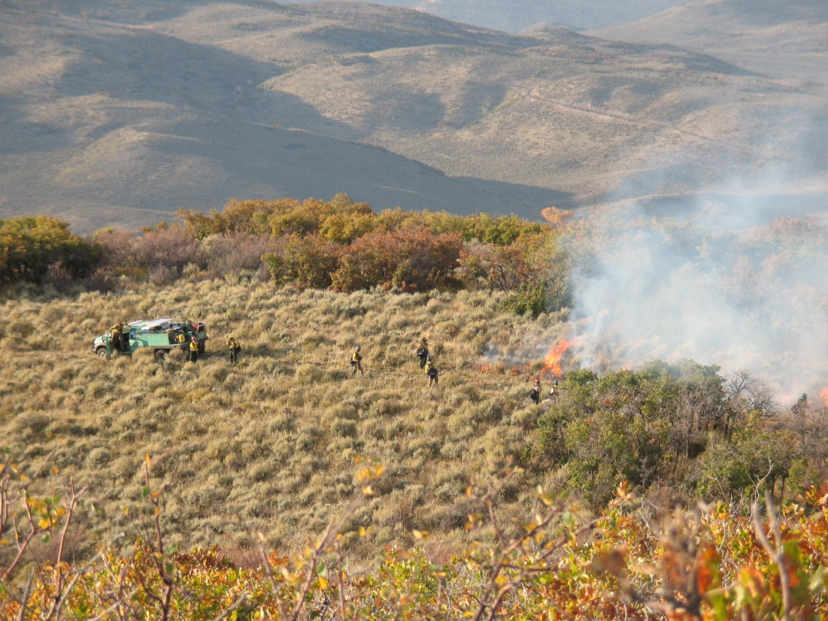

Review Team Members:

Tamera Randall-Parker - District Ranger, Ouray Ranger District GMUG NF,
Terry Tompkins - Fuels Specialist, Mystic RD, Black Hills NF
Jeff Vanis - AFMO, PSICC NF
Brenda Wilmore - Fire Use Specialist, Rocky Mountain Region -
Executive Summary

On 10/02/2008 the Indian Run prescribed fire was ignited in Routt County on the Indian Run State Wildlife Area. The burn was implemented by the Routt Zone fire management personnel of the Medicine Bow - Routt National Forest. At approximately 2100 on 10/02/2008 the prescribed fire was declared a wildfire. Containment was achieved shortly after 2100 that same day. The planned 79 acre prescribed fire eventually burned 284 acres. Two hundred and five of those acres were outside the project area and located on private property. No structures were involved; however three historical features (old cabin skeletons) were consumed.

Although no Forest Service acres were included in either the burn unit or the escape, the Rocky Mountain Regional Office requested a review as Forest Service personnel were responsible for the planning and implementation of the project and a large amount of private land was involved. Hence, on October 20, 2008 U.S. Forest Service Deputy Regional Forester, Antoine Dixon assembled a review team to evaluate the circumstances and events related to the escaped Indian Run prescribed fire. The delegation of authority requested that the review report include the elements in the Interagency Prescribed Fire Planning and Implementation Procedures Guide for an escaped prescribed fire that has been declared a wildfire. The review team utilized the Facilitated Learning Analysis (FLA) approach with the goal of improving future prescribed fire programs by gathering lessons learned from the individuals involved.

The Facilitated Learning Analysis was held the week of October 21, 2008 at the Hahns Peak/Bears Ears Ranger District in Steamboat Springs. Weather restricted the team’s ability to conduct a full site visit; however the fire site was viewed from a good vantage point on October 22, 2008. Most of the key individuals who were directly involved in the prescribed burn participated in the FLA. The FLA utilized the After Action Review (AAR) format to discuss the planned actions, what actually happened, why it happened, and what could be done next time to develop the lessons learned from the experience. The Burn Boss, Holding Boss, Firing Boss, and Type Three Incident Commander led the AAR discussion. Those involved were encouraged to be open, forthcoming, and frank in their discussion of actions. Participants were assured that the intent of the FLA was not to apply blame, but was an opportunity to learn from the escape, discover areas of weakness in the implementation and/or planning of the prescribed fire, and achieve overall organizational learning. All pertinent documentation, including burn plans, agreements, NEPA documentation, maps and photographs were reviewed by the team. Clarifying questions were directed to the FLA participants.

The Indian Run Burn Boss, Zone FMO, and the other FLA participants documented numerous lessons that were discussed during the FLA process. The review team working with the participants categorized the lessons learned into two groups, causal and contributing factors. Causal factors included overlooking critical holding points, identification of values at risk and prioritizing appropriate time to review project design and burn plan elements. Two contributing factors to the escape were the location of unit boundaries and absence of an agreement with an adjacent private land owner.
Indian Run Prescribed Burn Narrative and Chronology

The Indian Run Project is an interagency prescribed fire project that lies within the Yampa Ranger District of the Medicine Bow - Routt National Forest, the Indian Run State Wildlife Area, and the Little Snake Resource Area of the Bureau of Land Management. There are four burn units in the project. Two small hand firing units, Units 1 and 2, lie completely within the Indian Run State Wildlife Area on northwest facing slopes in the Beaver Creek drainage. Units 3 and 4 lie further south along both sides of Beaver Creek. Units 3 and 4 are much larger units that will be aerial fired and encompass acreage from all three agencies. A Wyden Agreement is in place for ignition on the Indian Run State Wildlife Area. The project is jointly funded with Forest Service hazardous fuels, Rocky Mountain Elk Foundation, and Habitat Partnership Program funds. The goal of the prescribed fire is two-fold, create a mosaic of age and structure classes in the mountain shrub ecosystem that will improve wildlife habitat and break-up fuel continuity to lessen fire intensity in the event of a wildland fire. This was the Yampa Ranger Districts first experience with fall burning in these fuel types.

In the escape that occurred on October 2, 2008, fire spread rapidly from Unit 1 (79 acres) east onto the adjacent private land. A verbal agreement had been negotiated with the landowner for access to the burn unit but a participating agreement to include private lands either in the burn unit or within the project area had not been agreed to. When the fire was contained late on October 2nd, 205 acres of private land had been burned. The following is a chronology of the events that lead to the escape.

October 1, 2008 – Blacklining Operations
Implementation resources were briefed at the staging area just east of Unit 1 at 1500. The goal of the day was to secure the top end of the unit with a blackline in the grass/sage flat (FM2) located along the east unit boundary. The resources on scene consisted of:

Burn Boss (RXB2)
Firing Boss (FIRB)
Firing Boss Trainee FIRB(t)
Holding Boss
3 Type 6 Engines (E-617, E-618, and E-652)
1 UTV equipped with 100 gallon tank and pump
1 Lookout
5 FFT2

The District Ranger, Zone FMO and Forest FMO all made appearances on or near the line at different points through the afternoon and evening.

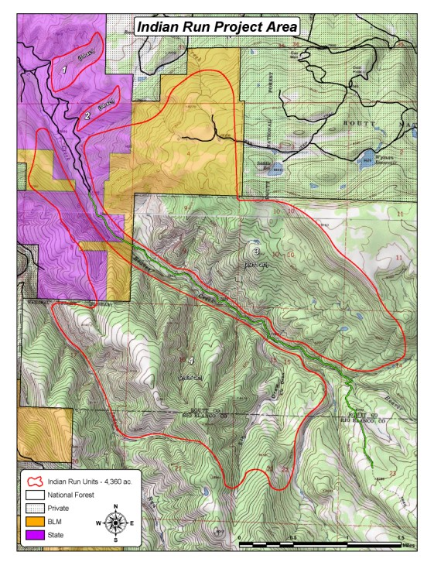
Indian Run Project Area. The escaped fire spread from Unit 1 upslope and
East onto the adjacent private land.

At approximately 1530 on 10/01/2008, the lighting crew conducted a test fire in the northeast corner of the unit. The test fire was judged to be successful. Blacklining operations were initiated and continued until objectives were met at 2230 that evening. Fuels consumed during the blacklining phase consisted of sagebrush with small pockets of Gambel oak and service berry. The topography was flat with good vehicle access throughout the majority of the blacklining area. During this shift the only difficulty encountered was lighting slow enough to complete the mission effectively and safely. The slow pace caused the blacklining to take longer than anticipated. The blackline was estimated to be one half to one chain wide upon completion at 2230. Crews bedded down for the night just off the unit in anticipation for main unit firing on 10/02/2008.

October 2, 2008 – Main Unit Ignition
Unit 1 is comprised of a steep north facing slope vegetated with Gambel oak and service berry (SH7). The burn objective for this unit was to create a mosaic in the mountain shrub type to improve wildlife habitat and to reduce hazard fuels. Implementation personnel were briefed on an overlook at the edge of the unit at 0730. Resources were assigned and a test fire was ignited. Due to shading and cool morning temperatures the initial attempt at ignition was unsuccessful. The Holding Boss and FIRB drove the blackline and reported that it was cold. A successful test fire was finally ignited at 1030.

Shortly after 1030 main unit ignition commenced with the objective of bringing fire from the established blackline at the top of the unit down both the north and south flanks to Beaver Creek road which was the western control line. Both flanks of the unit were bordered with bald ridges.

Two small firing modules worked the flanks concurrently from the flat blacklined area at the top of the unit downslope to Beaver Creek road in the drainage bottom. Group A fired the south flank while Group B worked the north flank.

E-618 was stationed at the top of the unit to patrol the blackline from the previous day. Engine access along the north flank enabled E-617 to assist Group B with their firing operations. However, this portion of the fire remained shaded limiting fuel consumption and fire spread. Consequently, Group B halted operations until burning conditions improved.

At 1130, as Group A moved west down the ridgeline on the south flank, the FIRB began firing along a contour north towards Group B about one third of the way down the slope. His attempt at a strip head fire was met with limited success as both temperature and relative humidity were at the low end of the prescription parameters and cloud cover was building over the area. Fire intensity would increase during brief periods of sun but diminish once the cloud cover
reestablished. Although the patchy burn pattern created by these short bursts of fire activity was meeting the mosaic objective in the burn plan, the short bursts of intensity were not making runs all the way to the blackline. After witnessing the characteristics of the FIRB’s ignition, the RXB2 attempted to continue the mosaic and limit the potential for a strong upslope run towards the east unit boundary by spot igniting the downslope side of the blackline. The RXB2
progressed from south to north along the topographic break that separated the blacklined grass/sage flat from the main unit tossing fusees just off of the ridgeline into the oak and service berry (SH7) fuels. Again, this attempt was met with limited success as cloud cover continued to increase over the burn area.

At 1330 Group B was still struggling to get fire to carry along the north flank. To generate intensity and increase headfire spread in the targeted oak and service berry, the FIRB(t) suggested switching tactics to ignite along the bottom end of the unit. The Holding Boss and RXB2, after discussing the benign fire behavior that had been observed to this point, agreed that firing off the bottom of the unit was an acceptable tactic. At this time E-617, E-652 and the UTV were on the road along the north and west perimeter assisting Groups A and B. E-618 continued to patrol the blackline at the top of the unit.

Around 1400 it rained briefly diminishing the low intensity fire behavior further. The RXB2 adjusted the goal of the day from attempting to meet the burn unit objectives to completing a blackline around the unit perimeter.

At approximately 1500, the cloud cover began to break up and fire behavior began to increase. Firing ceased about 1530 and implementation personnel began patrolling the unit perimeter.
E-617 left the bottom of the unit to refill before joining E-618 at the top of the unit. Repositioning E-617 took at least 20 minutes.

At approximately 1600, the Holding Boss called E-618 which had been patrolling the blackline all day. They responded by saying they had a spot that was about four acres in size and that they were trying to catch it.

All of the resources at the bottom of the unit (west end) began the 20 minute commute to assist E-618 with the rapidly growing spot fire established outside of the blackline at the top (east end) of the unit. Within 10 minutes, E-618 reported the spot had grown to 15 acres in size.

By this time E-617 had refilled and was the first assisting resource to arrive on scene. The Holding Boss directed E-617 to assist E-618 and attempt to anchor and flank the spot fire. However, the fire behavior was beyond the capabilities of the type 6 engines and they both disengaged, retreating to a safe location.

Upon arriving at the top end of the unit, the Holding Boss consulted with the RXB2 (who was still enroute) about containing the spot by burning out from a road that was located on the adjacent private property. The RXB2 agreed that the Holding Boss should utilize E-652 and the UTV to burn off of the road if they felt they could accomplish the burn out safely. Within 15 minutes it was determined that burning from the road would not contain the fire and resources disengaged.

When the RXB2 arrived on scene all resources were accounted for and staged in a safe area. The RXB2, FIRB and Forest FMO evaluated containment strategies commensurate with the fire activity on the private land. The Holding Boss suggested burning off of a road near the northeast portion of the slop over. The RXB2 agreed and all resources were committed to this operation. By this time the burn period was nearing conclusion and fire behavior was beginning to moderate. However, in the evening twilight and residual smoke, burn personnel were unable to determine the actual size of the spot fire.

At approximately 2100 Craig Dispatch contacted the RXB2 to relay a fire report from a guest ranch located east of the burn unit. The ranch was concerned that the fire may be encroaching upon one of their guest cabins (the cabin in question was at least two miles from the burn site). Because the fire had burned private land, there was a hint of public concern, no one knew exactly how big the spot was, and the spot weather forecast predicted warmer weather the following day, the RXB2 made the decision to convert the fire from a prescribed fire to a wildland fire shortly after 2100 on October 2, 2008. In the transition the FIRB became the ICT3.

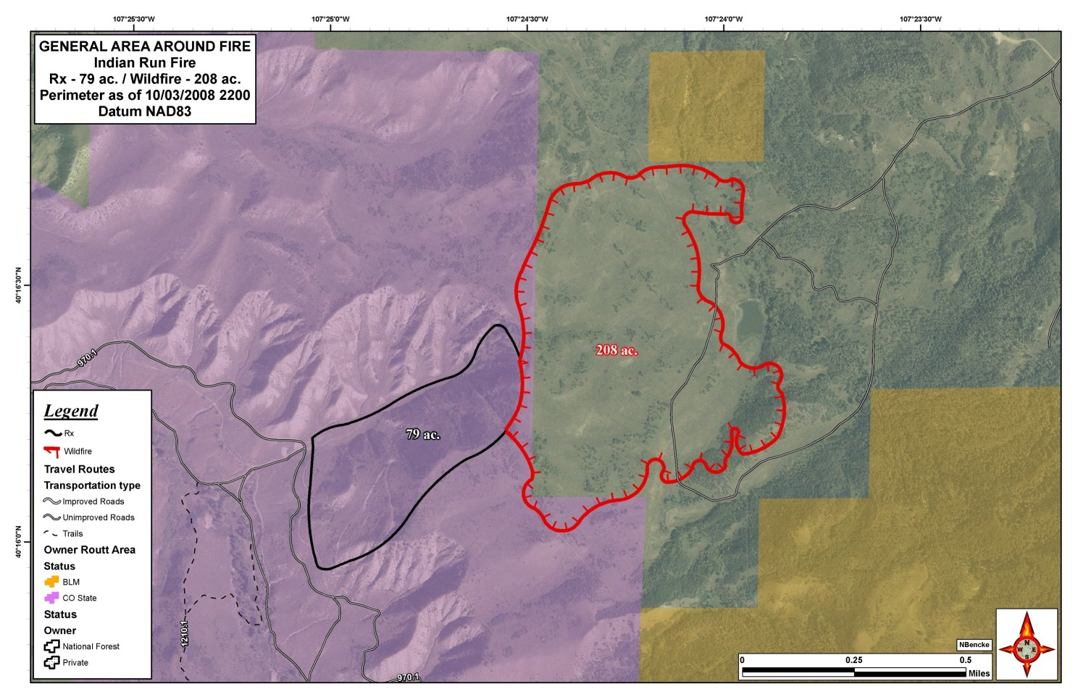
Final Indian Run fire Perimeter.
Lessons Learned by the Firefighters

Causal Factors

1. Identify Critical Holding Points/Values at Risk – Fire personnel agree overlooking critical holding points was a causal factor in the escape. The adjacent fuels at the top end of the unit were significantly different and supported more aggressive fire behavior than the fuels that had been modeled in the burn plan and complexity analysis. Holding forces didn’t focus on this area once the blacklining was complete and the main unit ignition had begun. Weather on the day of ignition had been cloudy and the unit had even experienced some rain early in the day contributing to the lack of focus at this critical holding point during implementation. The burn boss stated “I should have had another engine on the top of the slope”.

2. Fire Management Burden Shift - Due to the many administrative tasks now being placed upon fire management it can be challenging to devote adequate time to the planning and review of the burn plan, which requires undivided attention. The Zone FMO defined many challenges that although not insurmountable were identified as causal factors in the escape. Proper prioritization for critical work must be made. Challenges include; managing fire and hazard fuels with a small staff (the zone has only had a full staff for a few months), and day to day distractions such as IQCS, ASC, TFM, etc. In addition, the Medicine Bow/Routt has been greatly affected by the current Mountain Pine Beetle (MPB) epidemic which has generated much public and political interest. As a result, many of the beetle forest FMOs have become a focal point for project planning, funding, and accomplishment.

Contributing Factors

3. Unit Design and Project Boundary – Not a causal factor in the escape but was likely a contributing factor. Fire personnel need to evaluate and discuss the project unit boundaries candidly with other resource specialists during the NEPA process. Burn unit and project boundary design should be evaluated again while preparing the burn plan. This is an additional opportunity to discuss any modifications that may be needed in either the NEPA or the burn plan. One participant made this comment “Don’t tell the ID Team/District Ranger you can do things that you can’t. Make sure the project boundaries are defendable.”

4. Agreements/Wyden Amendment – Not a causal factor in the escape but was likely a contributing factor. Fire personnel feel units in this project would have been more defensible if the project boundary had included the adjacent private property. Having an agreement with the private landowner would have provided a more defensible holding location (i.e. using the existing road on the private property). Fire management and implementation personnel agree that the conversion to an escaped prescribed fire was directly related to the encroachment onto private property. During the course of this review it was discovered that the Colorado Division
of Wildlife agreement referenced the Colorado master agreement for prescribed fire. However, upon more research it was discovered that the Colorado Division of Wildlife is not a signatory to the master agreement and therefore this was not the proper document to tier to, nor was it clear if tiering is even necessary.

Incorporating High Reliability Organizational Principles
into Prescribed Fire Planning and Implementation

During the AAR the firefighters identified multiple lessons learned. The remainder of the report is an attempt to enhance the lessons learned by approaching the review from an outsider’s perspective and with the principles of High Reliability Organizations (HROs) in mind.

A HRO is an organization that operates in a high-risk environment and yet, when compared to other organizations, maintains a relatively low accident/error rate. This low accident/error rate is attributed to a process for thinking about the work environment that is called ‘mindfulness’. The five key elements of HROs are categorized into Mindful Anticipation and Mindful Containment as follows:

Five Key High Reliability Organization Principles

Mindful  Anticipation | Preoccupation with  Failure | Identify and respond quickly to conditions that can lead to failure
Mindful  Anticipation | Reluctance to Simplify | Seek and maintain a diversity and complexity of perspectives
Mindful  Anticipation | Sensitivity to Operations | Maintain constant vigilance to operations and updating our understanding of events based on observations
Mindful  Containment | Commitment to Resiliency | Respond decisively but adapt to unexpected developments
Mindful  Containment | Deference to Expertise | Defer to those with the greatest expertise and firsthand knowledge of the developing events

The overall goal of ‘mindfulness’ is to perform a more thorough job of anticipating unexpected events before they occur. If and when unexpected events do start to unravel, through ‘mindfulness’ we can contain them before they become massive problems. HROs use the five principles of mindfulness to constantly update expectations of what will happen. By using this
process and continuously implementing these five principles, these organizations do a much better job of anticipating and containing unexpected events.

“Specifically, when people follow these five principles of mindful organizing they weaken tendencies to:
- Look solely for confirmation of their hunches
- Develop tunnel vision under pressure
- Misunderstand and misestimate the complexity of events
- Treat unexpected deviations as normal
- Blame others for error
- Discount worst case scenarios, and
- Underestimate the rate of change

“If these tendencies go unchecked they can lead to unreliable performance, escaped fires, injuries, and fatalities. Efforts to reverse these tendencies are much harder than they look. They’re hard because-to organize mindfully-you have to forgo the ‘pleasures’ of attending to success, simplifying, planning, following checklists, and pushing decisions up the chain-of-command.”
Karl Weick, co-author “Managing the Unexpected”

These ‘mindful’ ideas and HRO principles were used to evaluate fire program activities through the seven required escaped fire review elements defined in the Interagency Prescribed Fire Planning and Implementation Procedures Guide (July 2008). Within each of the review elements that lend itself to ‘mindful’ consideration, key HRO principle(s) are suggested and questions are posed in an attempt to inspire a ‘mindful’ approach applicable to all prescribed fire practitioners.

Interagency Prescribed Fire Planning and Implementation Procedures Guide Required Review Elements

1. An analysis of seasonal severity, weather events, and on-site conditions leading up to the wildfire declaration:
The summer fire season on the unit was characterized as slow, with few fires and wetter-than-normal conditions. Measured live fuel moistures recorded three weeks prior to implementation show no indication of unusual dryness. The closest representative RAWS, Deadhorse, (Station ID 051404) indicates seasonal severity was near normal with ERC’s trending below the 90th percentile since early August, 2008.
The spot weather forecast for October 1st and 2nd and the on-site weather observations confirm that the burn was conducted within the environmental prescriptive parameters defined in the burn plan.

Indian Run Environmental Prescription for Main Unit Ignition
Fuel Model SH7

Air Temperature (ºF) | Relative Humidity (%) | 1 Hour Fuel Moisture (%) | 10 Hour Fuel Moisture (%) | 100 Hour Fuel Moisture (%) | Mid-Flame Wind Speed (mph)
65-75 | 15-35 | 5-9 | 7-11 | 9-13 | 0-10

Outflow winds from a passing thunder cell on the afternoon of October 2nd temporarily raised mid-flame wind speeds to 8-10 miles per hour and likely lofted the ember(s) that established the spot outside of the burn unit. The spot weather forecast for October 2nd did predict “isolated thunderstorms developing over the higher terrain to the south in the afternoon,” and “wind gusts as high as 40 mph in the vicinity of thunderstorms.”

The spot weather forecast also indicted warmer conditions would be present in the burn area on October 3rd. The predicted change in weather contributed to the implementation team’s decision to convert the Indian Run prescribed fire to a wildfire late on October 2nd after the fire had spread onto the adjacent private land. AAR participants were in agreement that the spot weather forecasts were accurate with the exception of the 40 mph wind gusts that did not materialize in the vicinity of the burn unit.

The HRO perspective: Surprises occur in a number ways including 1) an event you know will happen, when it will happen, and in what order, but you discover that the timing is off, 2) an event for which the expected duration of the event proves to be wrong, or 3) an expected event, but of the wrong amplitude.

- Preoccupation with Failure – Consider how a wind gust up to 40 mph might affect fire behavior and overall implementation of the project. Was this addressed in the planning process? Should implementation proceed if it was not?
- Reluctance to Simplify – Is there a tendency to perceive the potential for thunderstorm downdrafts as a normal afternoon weather scenario?
- Sensitivity to Operations – How can/will the burn organization adapt to a weather event that falls outside the prescriptive environmental parameters?
- Commitment to Resiliency – Does the burn plan adequately address strong winds, and have the implementation personnel been briefed on how to respond to such an event? Is there more than one contingency option?
2. An analysis of the actions taken leading up to the wildfire declaration to determine consistency with the burn plan.
The broadcast burn was declared a wildfire by the RXB2 on the evening of October 2nd and transitioned to a type three organization with the FIRB becoming the ICT3. The transition from a prescribed burn to a wildfire was prompted by the spot fire being on private lands and the spot weather forecast indicating a warmer weather pattern would persist through the next burning period. The transition was smooth and the key positions were filled by qualified individuals from the prescribed burn organization. AAR participants indicate the transition from the planned event, management ignited fire, to wildland fire suppression was conducted smoothly.

The HRO perspective: Mindful containment includes 1) a decisive response and adaptation to unexpected developments and 2) a deference to those with the greatest expertise and firsthand knowledge of the developing events.

- Commitment to Resiliency – Are the burn units designed in a defendable manner should small errors (i.e. spots or slop-overs) occur? Have specific critical holding points been identified? Does the contingency plan identify easily distinguished trigger points and fall back options to enable a rapid transition from lighting fire to fighting fire?
- Deference to Expertise – Were comments or diverse insights sought during any phase of the project? Should outside opinions be sought when burning outside of the typical burn window (i.e. fall vs. spring)?

During the AAR discussion, the review team learned that the Burn Boss had employed the Deference to Expertise principle. Rather than attempting to keep control of the situation by himself he assigned a more experienced Incident Commander (IC) to mange the escape. Weak signals that were missed will be explored in question seven.

3. An analysis of the prescribed fire burn plan for consistency with policy:
The Indian Run Burn Plan is tiered to the Indian Run Fuels Reduction and Wildlife Habitat Improvement Project, (Decision Memo, April 2007). The Burn Plan incorporated the Design Criteria and Resource Objectives established in the Decision Memo. The Indian Run Prescribed Fire Plan was found to be consistent with policy in that it addresses all of the elements specified in the Interagency Prescribed Fire Planning and Implementation Procedures Guide (July, 2008). The plan was prepared by a qualified RXB2, reviewed by a qualified RXB2, and approved by a qualified Agency Administrator. However, many of the core elements in the plan contained ‘weak signals’ that indicated potential for an undesirable outcome. These core elements include the unit design/project area description, complexity analysis, environmental/fire behavior prescription, and holding and contingency sections of the plan.

Project Area Description – A project area map depicting the unit perimeters, topography and land ownership were used to satisfy this required burn plan element. Had a narrative for each unit been included, details such as fuels, slope, aspect, placement of control line and critical holding points could have been clearly identified both inside and adjacent to the unit. A unit narrative might also trigger discussion during the burn plan review and unit reconnaissance.

Prescribed Fire Complexity Analysis – Although the Indian Run Prescribed Fire was rated a moderate complexity project overall, the majority of the elements were rated low including; off-site values, the risk of escape and potential fire behavior. Many of the rationale statements referred to ‘typical’ conditions despite the fact that Units 1 and 2 were slated for fall ignition which was expanding the normal burn window experience for planning and implementation personnel. The Prescribed Fire Complexity Rating elements can be used as a stimulus for ‘mindful’ consideration/vigorous discussion that can assist units in uncovering ‘weak signals’ which can then be mitigated prior to implementation.

The HRO perspective: The overall goal of “mindfulness” is to perform a more thorough job of anticipating unexpected events before they occur. If and when unexpected events occur through ‘mindfulness’ we can contain them before they become massive problems. A recent summary of escaped prescribed fires found that multiple small problems, when combined, can effectively jeopardize the success of a burn. Many of these problems could have been mitigated through more comprehensive and complete planning and communication.

- Preoccupation with Failure – Has the ‘what could go wrong here question’ been asked through all phases of the project; from project inception (unit design) through post-ignition (patrol and mop-up)?
- Reluctance to Simplify – Can fire personnel implement the project in its final design? Have critical holding points been identified? Does the complexity rating have a lot of low and no change elements? Is there a tendency to base predictions on past success (i.e. this is a typical burn)? Have pressures from conflicting priorities and expectations influenced our planning, review and/or implementation decision-making processes? Were the preparation, review and implementation of the burn plan approached “mindfully”?
- Sensitivity to Operations – Was there adequate time to recon the project area and individual burn units during the planning, lay-out and pre-ignition process? Did all of the key burn personnel have an opportunity to recon the unit and offer alternate opinions prior to ignition?
- Commitment to Resiliency – Has the project been set up for success in the event of an unexpected development? Do all of the participants know what the alternative actions might be and are the resources in place to respond if needed? Have we allowed ourselves to be influenced by the perceived pressures from conflicting priorities and expectations? Do we have sufficient program options that enable us to be resilient enough to resist pressures to burn before we are ready?

4. An analysis of the prescribed fire prescription and associated environmental parameters:
The prescription element of the Indian Run Prescribed Fire Plan included separate prescriptions for the blacklining and unit firing phases of implementation. The black lining prescription modeled fire behavior with Fuel Model 2 and restricted maximum midflame wind speeds to four miles per hour. Blacklining occurred in a relatively open, grassy, transitional zone between the oak/service berry/snow berry (Fuel Model SH7) vegetation within the interior of the burn unit and tall thick sage immediately adjacent to the project boundary. Upon completion on October 1st, the blackline averaged 33 to 66 feet wide. The implementation team felt that the blackline had adequate depth to hold the burn and that the ‘hard part’ of the project had been successfully completed. On the morning of October 2nd , the blackline was reportedly cold with no smokes showing and frost present.

Holding calculations to determine the minimum number and type of resources to keep the fire within the burn unit were based on the black lining prescription which limited midflame wind speeds to four miles per hour. Other holding resource calculations assumed; Fuel Model 2 fire behavior characteristics, head fire attack, Type 6 engine access, and an immediate response time.
The unit’s interior oak/service berry/snow berry vegetation was modeled using SH7 and allowed mid-flame wind speeds up to 10 mph and flame lengths up to 19 feet. (See main unit prescription in Element 1.) Environmental conditions remained within prescription throughout the black lining and implementation phase.

Indian Run Environmental Prescription for Black Line
Fuel Model 2

Air Temperature (ºF) | Relative Humidity (%) | 1 Hour Fuel Moisture (%) | 10 Hour Fuel Moisture (%) | 100 Hour Fuel Moisture (%) | Mid-Flame Wind Speed (mph)
65-75 | 20-40 | 5-9 | 7-11 | 9-13 | 0-4

However, dense, four to six foot tall sage existed immediately adjacent to the top unit boundary. This change in fuel type was not modeled for fire behavior in the event of an escape nor had resource production capabilities been determined for this change in fuel type which AAR participants reported to be more characteristic of Fuel Model 4 than Fuel Model 2. Once the spot occurred (likely from a burning oak leaf lofted over the black line) fire behavior in this tall dense sage was very intense with reported flame lengths in excess of 50 feet.

The HRO perspective: Mindful anticipation is paramount in this burn plan element as even a minor miscalculation could result in an unfavorable snowballing effect during implementation. The environmental parameters and fuel models used in the fire behavior analysis help determine project complexity and the detail needed in several other elements in the burn plan (i.e. pre-burn considerations, ignition, holding, and contingency).

- Preoccupation with Failure – Has the potential fire behavior outside the unit been addressed? Will any of the fuels in the burn area support spotting? What is the probability of ignition in the adjacent fuel bed?
- Reluctance to Simplify – Was the holding plan developed to respond to the fire behavior prescription? Can the resources listed in the containment calculations actually access the critical holding points and what tactics will the potential fire behavior allow?
- Sensitivity to Operations – Does the spot weather forecast predict weather parameters outside of the prescription window? Is there a section(s) of the unit that is vulnerable to escape under the high end prescriptive parameters?
- Commitment to Resiliency – Are the holding and contingency plans based on potential fire behavior outside the unit at the high end prescription parameters? Is the blackline deeper than the maximum spotting distance?
- Deference to Expertise – Is this is a new burn ‘window’ for the planners and implementers (i.e. is the unit expanding burning operations from a typically spring burn window to a fall window)?

5. A review of approving line officer’s qualifications, experience and involvement;
The team found the District Ranger was qualified to sign the Indian Run Prescribed Fire Burn Plan. The district ranger was involved throughout the entire project.

6. A review of the qualifications and experience of key personnel involved.
A review of IQCS records confirm the key individuals on the Indian Run Prescribed Burn were qualified for their positions. In addition, the burn plan was prepared and reviewed by qualified individuals.

7. A summary of causal agents contributing to the wildfire declaration.
‘Weak signals’ identified during the review of the documents and the AAR discussion including unit design and holding and contingency planning were the primary factors that contributed to the wildfire declaration..

Unit Design – Mitigation measures designed to protect resource values limited options for unit placement on the landscape. As evidenced in the attached maps, all of the units have mid-slope boundaries and some have long doglegs that will be hard to defend without significant prep-work. In addition, prescribed fire effects were analyzed by individual burn unit rather than over a larger project area hence, each burn unit is considered a separate project area. This approach limits the range of adaptive management options that could be considered if the burn units need to be redesigned for more defensible implementation and holding/contingency planning.

Holding Plan – Because the holding plan describes actions to be taken to keep the fire within the burn unit it should be developed with careful consideration of many of the other key burn plan elements (i.e. unit description, unit complexity, values at risk, and the fire behavior prescription).
In the Indian Run escape the ‘snowball effect’ begins to coalesce in this required burn plan element. Most of the causal factors contributing to the identification of this element as containing ‘weak signals’ have been discussed previously in question four. However, prescribed fire practitioners should be aware that the Interagency Prescribed Fire Planning and Implementation Procedures Guide specifically states that the holding and contingency plans must consider: “Fire behavior characteristics for fuel models within the maximum spotting distance and/or adjacent to the project boundaries. These predictions must be modeled using fire behavior model runs or empirical evidence of the hottest, driest, and windiest prescription limits in the Prescribed Fire Plan, along with the most extreme environmental conditions (slope, aspect) identified.”

Contingency Plan – Because the burn units were considered individual project areas and no analysis had been completed outside of the burn unit boundary the contingency options available to the prescribed fire planner were severely limited. In addition, language in the contingency element placed all responsibility for deciding specific containment actions on the burn boss in the event of the fire exceeding the burn unit boundary. The only trigger point for initializing the undefined ‘specific actions’ was that fire had spread outside the burn unit. The plan also states that no additional resources would be placed on stand-by for this burn as on-site resource capabilities were adequate to control fire spread.

The contingency plan should consider possible but unlikely events and the actions needed to mitigate those events. The plan should establish trigger points or limits that indicate when additional actions and/or resources are needed. If the contingency actions are successful at bringing the project back within the scope of the prescribed fire plan, the project may continue. If contingency actions are not successful by the end of the next burning period, then the prescribed fire must be converted to a wildfire.

The HRO Perspective – “Multiple small problems, when combined together, can effectively jeopardize the success of the burn. Many of these problems could have been mitigated through more comprehensive and complete planning and discussions.”
Prescribed Fire Escapes and Near Misses Lessons Learned, October 2008

- Preoccupation with Failure – Did we ask ourselves what could go wrong and incorporate the necessary mitigations into the plan? Did we ask ourselves ‘what if …’ to challenge our expectations and assumptions?
- Reluctance to Simplify – Are the fuzzy or hard to explain portions of the plan addressed in detail or skimmed over? In preparing the burn plan did we use the interagency template as a checklist or as a mechanism to identify and mitigate ‘weak signals’? Have we looked at fuels conditions and resource values outside the unit with the same scrutiny as inside the units? Is there an expectation that coordination and communications will naturally fall into place if an unexpected event occurs? Have pressures from conflicting priorities and expectations influenced our planning, review and/or implementation decision-making processes?
- Sensitivity to Operations –Are the most experienced resources aware of and located near the critical holding points?
- Commitment to Resiliency – Has an optimistic attitude set the project up for a reactionary response if something does go wrong? Will this approach place an undue burden on the burn boss in what is likely a high stress chaotic environment?

In summary, a more ‘mindful’ approach to planning, review and implementation of the Indian Run Prescribed Fire may have reduced the need to transition to a wildfire during project implementation. It is strongly recommended that all prescribed fire practitioners and agency administrators become familiar with the expectations and principles of ‘mindfulness’ as they apply to High Reliability Organizations and, that all prescribed fire practitioners utilize the principles of ‘mindfulness’ when planning and implementing prescribed fire projects. Resources related to High Reliability Organizing are available on the Wildland Fire Lessons Learned Center website, http://www.wildfirelessons.net/HRO.aspx .

Finally, prescribed fire plan authors and reviewers should consult the Prescribed Fire Complexity Rating System Guide and the Interagency Prescribed Fire Planning and Implementation Procedures Guide which both contain detailed guidance to assist with plan preparation.

“We cannot guarantee that attempting to develop a High Reliability Organization framework for our prescribed fire and fire use operations will prevent escapes. That would be unrealistic. But, by working with this key learning organization concept, we are exhibiting leadership in a prescribed fire arena – hopefully, becoming even more assured that we are doing everything possible to lessen the chance of serious escapes, and to increase the chances of replicating our successes.”
Dave Thomas, Managing the Unexpected consultant

The unit design and holding considerations were discussed in the “Lessons Leaned by the Firefighters” as casual and contributing factors to the escape. The environmental/fire behavior prescription is discussed in Item 4 of the report.

