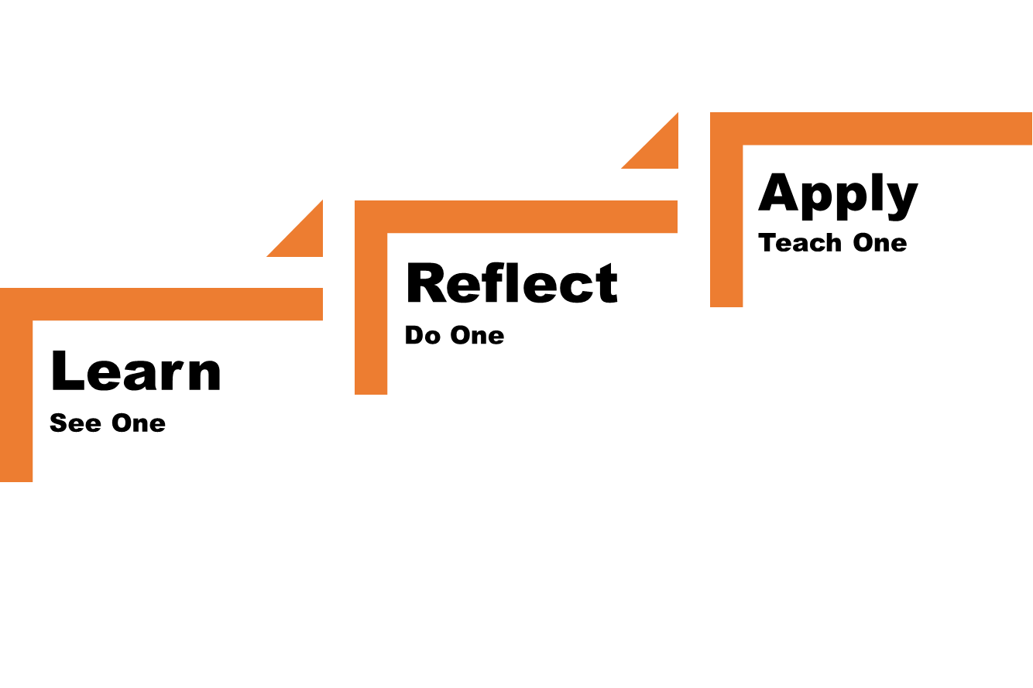**Topic**: **CPR and AEDs—Simple Knowledge Matters and Saves Lives Everyday**

**On September 6, 2017, hands-Only Cardio Pulmonary Resuscitation (CPR) was performed on a 58-year-old male in a fire camp. He survived thanks to training that anyone can do. An Automated External Defibrillator (AED) was utilized in the rescue, but did not recommend a shock to the survivor, it did not detect a shockable heart rhythm. In addition, the Incident Management Team worked quickly to have Advanced Life Support available to transport the survivor to the nearest Cardiac Hospital. While a helicopter was requested, heavy smoke conditions prevented it from being launched.**

**Hands-Only CPR is easy to learn and can be done by nearly anyone. Some studies have shown children as young as 9 can successfully apply this learning. CPR is a vital link in a person’s chances of survival.** **Hands-Only CPR is CPR without mouth-to-mouth breaths. It consists of two easy steps:**

* **Alert for Advanced Life Support via 9-1-1 or radio.**
* **Push hard and fast in the center of the chest.**

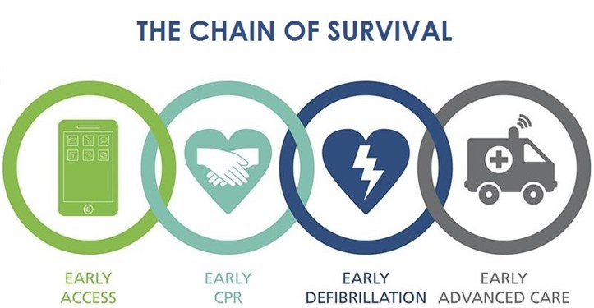

**We all have a potential link in the chain of survival for a person experiencing a cardiac event. When you get home will you take the time to learn these invaluable skills? Does your team or crew have an AED that is easily accessible? You have the capability to save a life!**

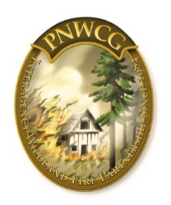

***This Safety Message was submitted by:***

**PNW RLS Team Aaron Pedersen and Damen Therkildsen,**

**with support from the Pacific Northwest Coordination Group**