**Topic**: **Cardiac Events –**

**Know the Symptoms!**

**Across the Pacific Northwest in 2017 on daily safety calls there was an uptick in cardiac events being reported on several incidents. Fortunately, all of the events had a positive outcome. In one instance, CPR was successfully performed. Two consistent themes emerged and included the importance of listening to one’s body through early recognition of the signs and symptoms—and the importance of a rapid medical response.**

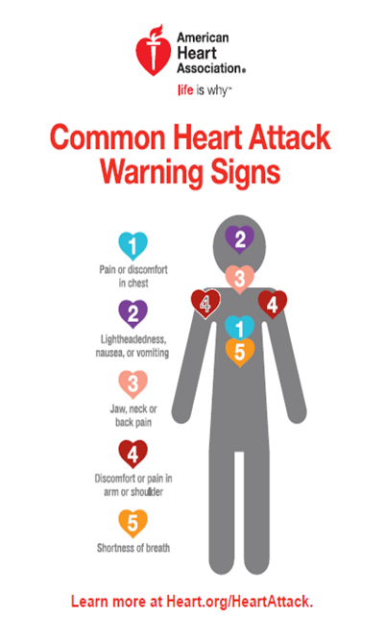

Knowing what is normal and abnormal with your body is essential. This goes beyond a cardiac event and into many aspects of our health and wellness throughout the fire season as well as in the off-season. Here are a few watch-out situations for a cardiac event—your heart does not always discriminate based on age:

* Chest discomfort. Most heart attacks involve discomfort in the center of the chest that lasts more than a few minutes, or that goes away and comes back. It can feel like uncomfortable pressure, squeezing, fullness or dull/sharp pain.
* Discomfort in other areas of the upper body. Symptoms can include pain or discomfort in one or both arms, the back, neck, jaw or stomach.
* Shortness of breath with or without chest discomfort.
* Other signs may include breaking out in a cold sweat, nausea, or lightheadedness.

**Apply the lessons learned here by ensuring yearly physicals, especially for those over 50, as the risk for cardiac arrest increases. Just as we perform routine maintenance checks on our vehicles, our bodies need regular check-ups to stay healthy and function properly. Pay attention to what your body is telling you and use wisdom to act appropriately when something feels wrong. We are all worth the investment.**

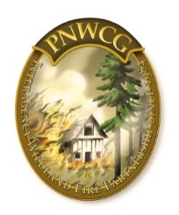

***This Safety Message was submitted by:***

**PNW RLS Team Aaron Pedersen and Damen Therkildsen,**

**with support from the Pacific Northwest Coordination Group**